Deep Learning with Keras
Jerry Kerata
- uses vscode (.py files) → convert to ipynb files
- Stand-alone keras install
- old TF version (1.3) - I have v2.1

Overview
- high level NN API
- can run on top of other libs: Tensorflow, CNTK, Theano
- written in Python
- Keras does not define or run the neural network – facilitates these operations via the specified backend
- keras comes with tensorflow (tf.keras) or can be installed independently
  - stand-alone install can use any backend
  - tensorflow install has GPU (tensorflow-gpu) and non-GPU versions
    - GPU usage requires CUDA toolkit
- building tensorflow from source can yield performance improvements for large models
- Jeff Hinton – father of neural networks
- steps
  - create model
  - add layers
  - compile model
  - train model (via fit)
  - evaluate performance
- changing the backend
  - update keras config (keras.json in home folder)
  - set env variable KERAS_BACKEND = 'tensorflow'
    - or CNTK or theano
    - overrides the config file setting
- model types
  - sequential – sequence of layers – connections auto-managed - easy
  - model class for use with functional API – complex NN with manual arrangement/connections – more powerful
- Jeff Heaton Guidelines for starting # of hidden layers
  - http://www.heatonresearch.com/2017/06/01/hidden-layers.html
# hidden layers | result
0 | Only rep linearly separable
1 | Continuous mapping from one finite space to another
2 | Arbitrary decision boundary
3 | Complex representations
  - Neuron count starting points – more is better until overfitting happens
    - > = size of input and <= size of output
    - (2/3 * size of input layer) + size of output layer
    - < 2 * size of input layer
  - keras model features
    - model.summary() show layers in sequence as text
      - layers, shape, # params (trainable)
      - uses name property from Dense as descriptor
    - plot_model()
      - graphical model hierarchy
      - connections illustrated
  - trainable param count is key to defining complexity of model and runtime (resource requirements)
  - callbacks – functions that can be triggered at key points with access to model state information
    - collect information
    - monitor progress
    - tune parameters while training
    - create checkpoints (resume at these later)
    - terminate training early (early stopping) – stop training if metric stops improving
      - terminate based on training accuracy or validation accuracy
    - API for user-defined callbacks
  - Saving – retaining and re-using
    - (HDF5)
      - .save(filepath)
      - .load_model(filepath)
      - save_weights – only weights – assumes model architecture is identical
        - save weights, try something different, restore if it didn't work out
      - load weights
        - byname – ignore architecture?
    - others
      - model_to_json, model_to_yaml, model_from_json, model_from_yaml – layers only – no weights/training – needs to be compiled and trained
      - save_
- Functional API
  - non sequential NN structures
    - mutliple inputs
    - iterative layers
    - multiple outputs
  - from keras.models import Model#replaces layer add
  - from keras.layers import Input#replaces first input layer
  - specify the model using inputs and outputs
    - model = Model(inputs=inputs, outputs=o)
  - summary and plot_model work same as before
- Layer Types – 70+ and custom layers possible
  - applicable for all layers
    - methods: get_weights(), set_weights(weights), get_config(), from_config(config)
      - weights as numpy arrays
      - config is a dict
    - attributes: input, output, input_shape, output_shape
    - for 'shared' layers (re-used): get_input_at(node_idx), get_output_at(node_idx), get_input_shape_at(node_idx), get_output_shape_at(node_idx)
  - common – basic
    - Dense – fully connected or output
    - dropout – drop a percentage (randomly selected) by setting inputs to this layer to 0 to prevent overfitting
  - shaping – first dimension is always the number of batches – typically not changed (None)
    - reshape – coverts input shape to output shape -e.g. Reshape((2,3), input_shape=(6,)) → (None, 2, 3)
    - flatten – convert to # tensors by 1 tensor - e.g. Flatten((None, 64,32,32)) → (None, 65536)
    - permute – change the order of the tensors – e.g. permute((2,1), input_shape=(20,40)) → (None, 40, 20)
    - RepeatVector – create copies of the vector – e.g. RepeatVector(3, input_shape=(None,32)) → (None, 3, 32)
      - used in RNN
  - merging – combine outputs - connects inputs froim two layer stacks (e.g. multi-input)
    - Note: uppercase vs lowercase first letter – different usage syntax
      - Subtract()[x1,x2] – functional API syntax
      - subtract(x1,x2) – python call syntax
    - Add/Subtract/Multiply – requires same shape tensors
    - Average/Maximum – same shape tensors
    - concatenate – tensor list and axis for concat – need to have same shape except for concat axis
    - Dot – dot product along specified axis
  - extension – add custom defined layers
    - lambda layer – faster – simple tasks
      - cannot contain trainable weights that are updated with backprop
      - options
        - inline – model.add(Lambda(lambda x: x**2))
        - with function
          - def sqr(x): return x**2
          - **Theano requires a function defintion for output shape
            - def sqr_shape(input_shape): return input_shape
          - model.add(Lambda(sqr, output_shape=sqr_shape))
    - Custom layer – complex tasks – existing keras layers were created with this
      - can use trainable weights
      - can be used
      - Class myLayer(Layer) – must inherit from Layer
      - must-implement methods
        - __init__ - specify output dim and call super(MyLayer,self).__init__(**kwargs)
        - build(self, input_shape) – weights to be dtrained - kernel, iniitalizer, and trainable – then calls super().build()
        - call – layer logic
        - compute_output_shape – how is output shape determined
        - usage:
          - model.add(MyLayer()) - sequential
          - x2 = MyLayer()(x1) - functional

  - convolutional layers (separate module)
  - RNN layers (separate module)
- Transfer Learning – leverage an existing train model and adapt to our needs
  - replace classifier with our own
  - train classifier on our classes (only training part of the node

Convolutional NN
- Always deep – 2+ hidden layers
- dev to address images and curse of dimensionality – 8million pixes input to 1000 neurons = 8 billion trainable weights * 3 channels = 24 billion weights
- translational invariance – identify something in different contexts e.g. big, small, mirrored, skewed, placement
- other applications: video, signal processing (1D), NLP, Combine with RNNs
- general structure
  - alternating convolutional (relu) and pooling layer
  - followed by some dense layers
  - maybe a softmax layer for classification
- extract features
  - edges
  - composite elements
- kernel matrix transformation applied to data matrix yielding a feature map
  - kernel size – filter values – stride (hor, ver)
    - transformation is dot product
    - filter values are trained weights -
- hyperparameters -
  - kernel size – width x height of each filter – small values better (3x3,5,7)
  - # filters – feature detection – common: 16, 32, 64, 96
  - stride – how much the filter moves each iteration – common: 1 (first layer)
    - larger stride is faster but reduces feature map size and information passed to next layer
  - padding – preserve dimensionality and use edges as much as inner
    - padding = 'same' setting ensures that output is the same shape as imput
    - default is not to use padding ('valid')
- Convolution passed to non-linear activation (ReLU – most common)
  - explicit activation layer after convolution
  - pass activation function to the convolution layer
  - ReLU prevents vanishing gradient
- Pooling layers (down-sampling)
  - goals
    - reduce dimensionality of data (reduce # of trainable weights)
    - generalize the information (to improve translational invariance)
  - max pooling is most common
    - look at a nxn matrix filter and apply a transformationt that outpus a single value
    - stride n for nxn matrix
  - input depth will be = output depth
  - subsquent conv+pool layers combine features identified in prior layer into larger features
  - final NN layers classify the combined features (e.g. face, cat, fred, etc...)
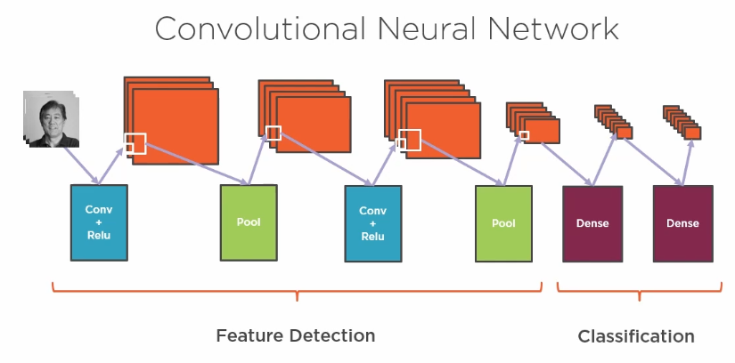

Recurrent NN – module 7
- Sequential dependence – context – time series
  - DNN issues - no memory of prior event or tracking of seequeces
  - same computation on each item in a sequence
  - user current and previous data
  - U – input matrix conditioned by weight matrix W (transition matrix)
  - V – output matrix
  - h - hidden state
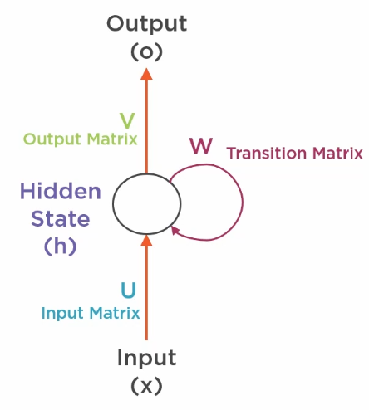
  - unrolling the diagram over time [for a single neuron?]
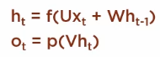
  - it is the weights for current state that are dpenedent on the weights of the prior state
  - Simple RNN - hard to train – back propagation – issue if values of weights move away from 1
    - exponential increase – exploding gradient
    - decreasing to zero – vanishing gradient – more prevalent problem – models stop improving
    - LSTM and GRU
      - LSTM
        - cell states added or removed with Gates
        - cell state is modified by interacting with the data at each time step with gates
          - forget gate – remove an item
          - input gate – add things to remember
          - output gate – determine current state output for this time
          - deeper explanation: http://colah.github.io/posts/2015-08-Understanding-LSTMs

      - GRU (Gated Recurrent Unit) – variant of LSTM – simplified
        - Update gate = comination for Forget and input gate
        - Merges hidden state and cell state
      - Keras layer types: SimpleRNN, LSTM, GRU
        - ConvLSTM2D – uses convolutions to transform data – e.g. convolution and LSTM for each frame of video
        - CuDNNGRU – CUDA support layer (Nvidia graphics card) – requires CUDA library and tensorflow backend
        - CuDNNLSTM – CUDA suppor layer for LSTM
      - Demo – RNN for sentiment analysis of IMDB movie reviews (shipped with keras)
- Keras specialty features
  - preprocessing
    - pad_sequence () make sure text string vectors are all the same length
    - skipgrams() - process word sequences – generate word couples
    - make_sampling_table() - creates sample probaility table for sample words (sused by skipgrams) – ensure equal sampling of words
  - batch normalization layer – normalizes output of prior layers activation function to prevent exponential gradient issue (mean near 0 and stdev close to 1)
  - dropout
  - Noise layers –
    - Gaussian Noise centered on zero to shift values from prior layer a little
    - Gaussian dropout
    - alpha dropout – maintain mean invariance from prior layer but reduce output
  - Keras datasets – sample data – standard for comparison
    - some preprocessing already done (e.g. labels for data)
    - images: MNIST, Fashion MNIST, CIFAR 10, CIFAR100 [color images]
    - Text: IMDB, Reuters (topics)
    - Regression: Boston Housing Price
  - Keras pre-trained models
    - Images: Xception, VGG16, VGG19, ResNet50, InceptonV3, InceptionResNetV2, MobileNet, DensNet121, DensNet169, DensNet201
      - most of would be too large to be practical train outside of a cluster
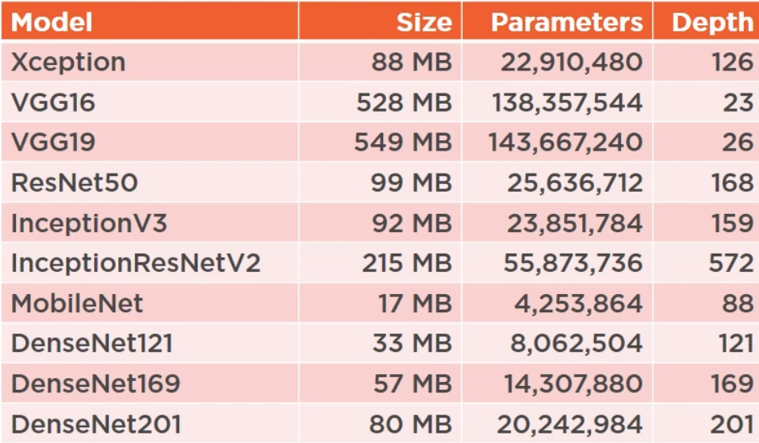
- Functional API
  - create a function that creates layers – facilitates re-use in other models or repetition in same model
  - e.g. Inception uses functions to create different types of layers used later in the model
  - use lists to pas multiple inputs and outputs
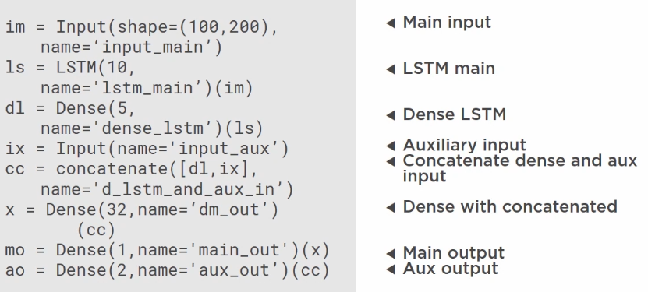
  - Next Steps?
    - http://keras.io
    - https://blog.keras.io/
    - Book
      - Deep Larning – Goodfellow, Benglo, Courville – http://www.deeplearningbook.org/
    - Standford CNN course materials – http://cs231n.github.io/convolutional-networks/
      - some of the lectures are on youtube
    - RNN/LSTM (Chris Olah) – http://colah.github.io/posts/2015-08-Understanding-LSTMs/
    - RNN applications (Andrej Karpathy) – http://karpathy.github.io/2015/05/21/rnn-effectiveness/

